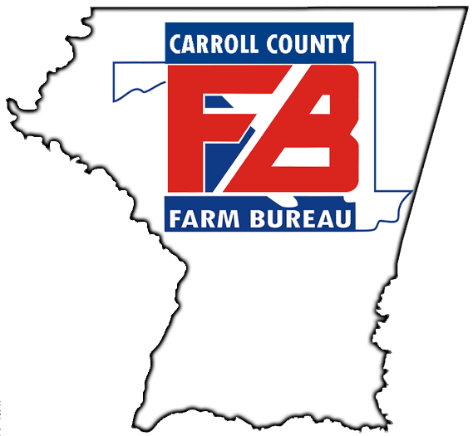

Carroll County Farm Bureau
Women’s Leadership Committee
2026 Scholarship Application

MISSION STATEMENT
The Joan Myers Memorial Scholarship has been established in 2026 by the Carroll County Farm Bureau Women’s Leadership Committee to honor the enduring legacy of Mrs. Joan Myers and her deep commitment to the community she served. Joan served as chairwoman of the CCFB Women’s Leadership Committee for over 30 years, volunteered with countless organizations, and was a strong leader in her community. The recipient of this scholarship MUST demonstrate meaningful community involvement, exemplary citizenship traits, and display strong leadership skills in both academics and extra-curricular activities while attending their high school and/or college. The award will go to a graduating high school senior or a current college student continuing their education. In recognition of Mrs. Joan’s distinguished career as an educator, strong consideration may be given to a student pursuing a career in education.

The Carroll County Farm Bureau Women’s
Leadership Committee will be offering
One $1,000.00 Scholarship

- Applicant must be a high school senior starting college in Fall 2026 OR a current college student studying at any community college, four-year college, or a technical school
- Selection will be made by a sub-committee from the Carroll County Farm Bureau Women’s Leadership Committee
- No student can receive the scholarship more than twice
- The scholarship will be paid directly to the college/university or technical school
- Applicant’s family does not have to be Farm Bureau members, however, priority will be given to those who are

Application Criteria

- Typed scholarship application is due by July 1, 2026
- Current high school or college transcript
- A resume which includes community involvement, citizenship traits, leadership skills, and extra-curricular activities
- Two letters of reference, including one from a teacher or professor with knowledge of the student’s academic and extra-curricular background
- A letter giving reasons why you have selected your program of study, your future plans, and any additional explanation as to why you feel you are deserving of this scholarship

Applications may be scanned and emailed to maryarasche@gmail.com or by mail to Carroll County Farm Bureau Women’s Leadership Committee, c/o Mrs. Mary Rasche, Chair, 3680 Senft Road, Taneytown, MD 21787. Applications MUST be received by July 1, 2026 at 11:59pm. Late applications will not be accepted.

The selection process will begin immediately and the recipient or their parents will be notified by phone once the selection is made. The scholarship will be awarded during the 2026 Carroll County 4-H and FFA Fair. The date and time of the award ceremony will be provided, please plan to attend.

SCHOLARSHIP DEADLINE IS JULY 1, 2026

Carroll County Farm Bureau Women’s Leadership
Scholarship Application

PERSONAL INFORMATION:

Full Name:____________________________________________________________________________
Home Address: ________________________________________________________________________
City, State, Zip: _______________________________________________________________________
Home Phone: ______________________________ Cell: ______________________________________
Date of Birth: __________________ Farm Bureau Membership # (if applicable):____________________
Is your family a Farm Bureau Member?_____________________________________________________
Parent or Guardian Name(s): _____________________________________________________________
Parent or Guardian Phone #______________________________________________________________
High School(s) Attended: ________________________________________________________________
Date of Graduation: __________________________________ High School GPA: __________________
Name of College or Trade School: ________________________________________________________
College or Trade School Phone: ____________________________ Fax: __________________________
College or Trade School Billing Address: ___________________________________________________
City, State, Zip: _______________________________________________________________________
Student ID #: ___________________Year in College: ______________ Current GPA: ______________
Major(s) and Minor(s): _________________________________________________________________
_____________________________________________________________________________________
How will this scholarship impact your schooling? ___________________________________________ _______________________________________________________________________________________________________________________________________________________________________________________________________________________________________________________________
_____________________________________________________________________________________
____________________________________________________________________________________
REFERENCES:
Please list two references below and attach their written letters of recommendation:
#1
Name: _______________________________________________________________________________
Relation to Applicant: _______________________________Phone: _____________________________
Email: _______________________________________________________________________________
#2
Name: _______________________________________________________________________________
Relation to Applicant: ______________________________Phone: ______________________________
Email: _______________________________________________________________________________

