Maryland 4-H– General Project Record
Name |  |  | 4-H Age
Primary Club Name
Years in 4-H
Project Area |  |  |  |  | Years in this Project
I have completed this record and believe all information to be complete and accurate.

Member’s Signature Date Parent’s Signature Date

_____________________ _______ ______________________ _______
Leader’s Signature Date Educator’s Signature Date

What goals did you set for your project this year and did you achieve them?
1.

2.

3.

What were four things you learned from completing this project this year?
1.

2.

3.

4.

What is one thing you would like to improve or do differently with your project next year?
Life Skills
Describe the Life Skills you used and what you learned in relation to your project.
Example Table
I used one or more of these Life Skills from the Targeting Life Skills Wheel | What I learned as a result of using this skill.
HEAD  Example: Problem Solving | When I was taking pictures I noticed that they were blurry. I had to take the time to look at my camera and instruction book to find out that I was using the wrong setting for the type of picture I was taking. I made the change to the setting and my pictures were no longer blurry.
HEART  Example: Sharing | I taught a group of junior 4-H members how to give a demonstration. I taught them what their posters should look like and how to set up their materials on the table and how to make note cards.
HAND  Example: Self-motivation | I wanted to learn how to sew a dress, but never had sewn before. I took the time to practice straight lines first, and then I made some pillows to learn how to line fabric up before I tried to make my dress. This helped me in learning about the sewing machine and different stiches.
HEALTH  Example: Healthy Life Choices | I learned a new sugar free cookie recipe this year that I made and shared with the residents of a local nursing home that my club visits. A lot of the residents were thrilled that they could enjoy the sugar free cookie that I made for them.

I used one or more of these Life Skills from the Targeting Life Skills Wheel | What I learned as a result of using this skill.
HEAD | 1.  2.
HEART | 1.  2.
HAND | 1.  2.
HEALTH | 1.  2.

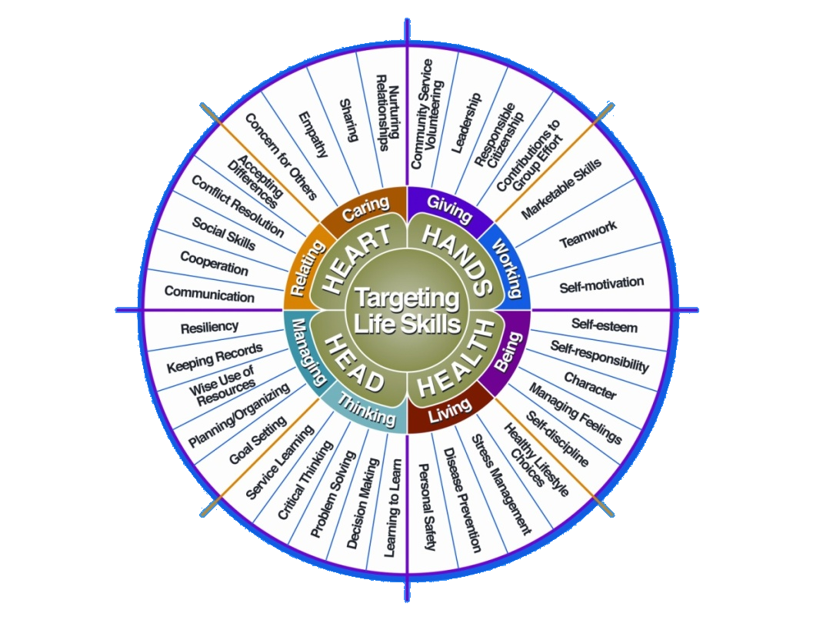
The diagram below shows many of the Life Skills learned in 4-H:

Courtesy of Iowa State University-Used with Permission 11/2012
Project Activities
Include: Field Trips, Judging, Workshops, Class Participation, etc.
All project activities listed should be about this project area only.
Date | Name of Activity/Event | Location  (School, Club, County, Regional, State, National etc.)

Project Communications
All project communications listed should be about this project area only.
Date | Type of Communication  (Speech, Demonstration, Visual Presentation, etc.) | Title | Location  (School, Club, County, Regional, State, National etc.)

Project Exhibits
Include: Fairs, Shows, Community Events, etc.
All project exhibits listed should be for projects in this area only.
Date | Exhibit | Location/Event | Placing  (if applicable)

Project Financial Journal

Table 1: All Expenses
(Paint, Poster Board, Baking Ingredients, Wood, Fabric, Supplies, Etc.)
Date | Description of Item or Expense | Cost
Total All Other Expenses

Table 2: All Other Income
Include all other income from project including premiums, etc.
Date | Description of Income | Income $
Total All Other Income

University of Maryland Extension programs are open to all persons and will not discriminate against anyone because of race, age, sex, color, sexual orientation, physical or mental disability, religion, ancestry, or national origin, marital status, genetic information, or political affiliation, or gender identity and expression.

