EAB Meeting
Wednesday, August 14, 2024
9:15-10-10:15 AM
Zoom Link:
https://umd.zoom.us/j/92126038203?pwd=S281NStXWDdDaU9wTTVMZmxBMGdLUT09
Meeting ID: 921 2603 8203 Passcode: 516979
Attendance:
Attendees:
Nancy Allred | Lajauna Smouse
Pam Hanna | Susan Smouse absent
Marilyn Kinkel absent | Sophie Sterling
Neva Leigh | Catherine Salam-Board Chair
Ann Sawyer absent | Maxine Yoon-AAMG Coordinator

- Chair’s opening remarks:
- Compost training certification was through University of Vermont and is focused on home composting; fee is $150; does not seem an appropriate experience for our MG community
b. Approval of Meeting Minutes-via email as per Catherine
- Coordinator’s Report Maxine Yoon (10 minutes)
. Naval Academy Dairy Farm update: Maxine reported that she had attended the Navy community informational meeting regarding their plans for the Dairy Farm. The Navy is receiving bids to convert the property to a solar farm facility to meet their Department of Defense (DOD) energy goals. Additionally, they want proposals to state that they are integrating the current use of the property such as the Extension office and farm. Many folks are concerned about the loss of the “Master Plan” of the Dairy Farm and it was at this point, Navy ended the meeting. The plan is that a proposal will be accepted by January 1, followed by environmental assessments of the property and feasibilities for parties concerned. The Navy is still accepting statements with concerns from all involved. Maxine referred us to maps and possible locations where we may move.
Maxine reminded us of dates that she will be out or teleworking including:
- Extension faculty onboarding tour upcoming
- Santa Fe for a National EMG Coordinator’s conference the week of 8/26
- Medical procedure and out of office or working from home 10/14-10/18.
- Medical reasons will cause her to be out in January and/or working from home for about 2 months.
- Maxine still plans to do the Fall training from the first week of September through the week before Thanksgiving. Most sessions will be in person with some sessions on Zoom. Speakers from the University of MD will participate periodically.

She will soon be moving onto a SAILBOAT !!!

OLD BUSINESS:
3. Speakers for monthly meetings Maxine (10 minutes)
- September –-
Dr. Dhruti Patel Maxine reports about 10 responses to invitation
i. Sept. 3 – in person at Dairy Farm, “Capture the Flavor”
ii. Sept. 10, Zoom, “Drying Herbs &amp; Spices”
b. October—Kevin Kelly, Dauphin Co. PA, “The Four-Season Garden: “A Photographic Tour”
c. November—Maxine, Review of UME Volunteer Policies; LOA for Maxine, every volunteer is supposed to review every 3 years, as well as the background checks
d. December – Holiday Party- Cindy Wells and Janet Clauson have been in contact with Harundale Presbyterian Church. Offered as a thank you, the Church will be given $300 taken from the raffle proceeds. The date of the Holiday party is Tuesday, December 10th.
e. January 2025—Paula Becker (DNR), “Living on the Edge”
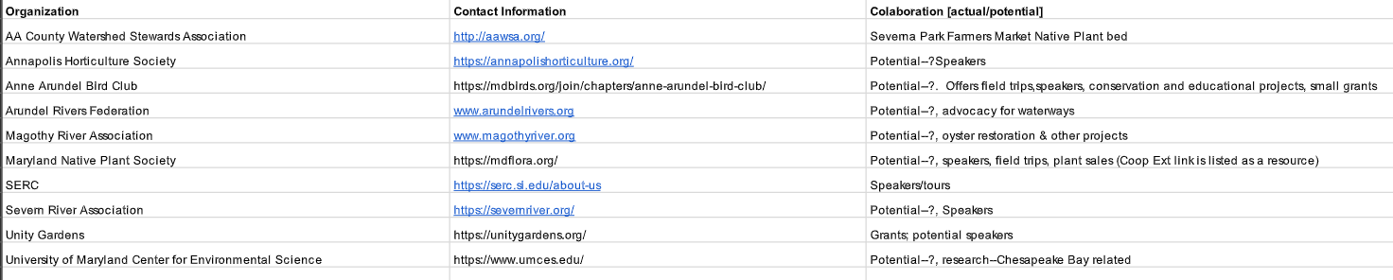
4. Community Partnerships Catherine/Neva/Marilyn (5 min)
Clarification of the things each group might offer. Neva is in the Bird Club and feels like the speakers they offer will be interesting for MG. Brochure indicates they want to further educate public. She referred to the website. Neva suggested inviting MG to speaker events, but Maxine says we would just need to have an invoice for an honorarium for them to visit us.
Nancy suggested we invite a member from these organizations to come to speak to us briefly about how we might support one another in our endeavors.
Sophie will connect with Native Plant Resources to see if/how we might collaborate.
We discussed our partnership with WSA for the Community Conservation Garden. They are providing us with liability insurance required by the Maryland Transportation Association (MTA) who owns the Severna Park Park and Ride ground where the Garden will begin in the Spring. Concerns about the lack of water sources were addressed and several folks said that water was brought to other sites without water access. It was suggested that we purchase a water barrel and mosquito dunks.

5. Project Chair Liaison Updates All (10 minutes)
Pam: Tawes Garden will be having a Native Plant Celebration on 9/14, and a bus ride to Hillwood Estate and Memorial Gardens on 9/25.
Has been unable to make contact with Jessica Reich regarding the Severn River school gardens.
Sophie: has requested to be put onto the agenda for next month’s meeting regarding changes that will be made to the Seed Swap project.
Catherine: See Financial Transparency below. Annapolis at Riva Road is wanting to buy a permanent location but there is a waiting list before we can do this. All are in agreement to move forward and soon as we are able to do so.
NEW BUSINESS
6. Financial transparency Catherine/Maxine (10 minutes)
https://drive.google.com/open?id=19Ddeu_jc5uOwr3RyHfYnmh-QKYrpBuWI&amp;usp=drive_fs
Catherine is requesting clarification of spending and where the money is coming from. She feels that the items are general, and we do not know the specifics. Maxine said that the EAC receives monies for operations and the money is then disseminated to the Food Bank and other projects. Sam and Maxine have been working together to organize and categorize the money. Some of the money comes from Master Gardener training and Master Gardeners who speak and receive an honorarium. Speakers do not request money but often receive honorariums anyway. The link above is to connect to the Google Drive to read the financial statement. Sam has taken Kristina Ratcliffe’s place. $1200 under Bay-Wise is likely from donations and selling signs. The fiscal year point is starting now. Motion made and seconded that Sam come to our next meeting, but it was also suggested that she be given questions ahead of time (and in the interest of time) as an addendum to the motion.
7. Items from EAB members All (as needed)
Pam asked if the Interns would be getting badges soon and Maxine responded that she will turn that over to Christy and have them mailed to the Interns.

Adjourn meeting (time)Motion was made to adjourn and seconded by Sophie.
8. Date of the Next Meeting- 9/18 Ann

